**What You Need**

* MSP430 TI LaunchPad with the Blink program installed (As your homework will be assessed individually, bring your own LaunchPad.)
* Laptop (The Lab computers are mostly unreliable, so bring it.)
* myPartsKit & Breadboard (You will be needing many jumper wires and male to female connects so both partners need to bring their own my-parts kits or else points will be deducted.)
* a 16x2 LCD

**Analog to Digital Conversion on the MSP430**

Liquid Crystal Display (LCD) is widely used in various electronics’ applications. It is commonly used in various systems to show different status and parameters. LCD16x2 has 2 lines with 16 characters in each line. Each character is made up of a 5x8 (column x row) pixel matrix.

In an LCD, liquid crystal material is sandwiched between two sheets of glass. As long as no voltage is applied to the transparent electrodes, the liquid crystal molecules are aligned parallel to the glass surface. When voltage is applied, the molecules turn perpendicular to the glass surface. Their optical characteristics vary depending on their orientation. Therefore, the quantity of light transmission can be controlled by combining the motion of liquid crystal molecules and the direction of polarization of two polarizing plates attached to the outer sides of the glass sheets. LCDs utilize these characteristics to display images.

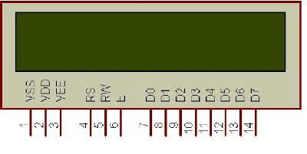

Fig 9.1- LCD pins and functions

**Procedure**

Part 1 – Demonstrate Your Prelab to a TA

Open Energia on your laptop and show the LiquidCrystal tab in the Examples drop-down menu. You and your partner must each do this step as the prelab is an individual assignment, not a group assignment.

Part 2 – Insert the LCD on the Breadboard (Now you may work with your partner as a team.)

Connect the LCD to your Breadboard such that all the pins of the LCD are either on line ‘a’ or ‘j’. Place the first pin of the LCD along the row of the Breadboard marked as ‘1’. Refer the figure below to reduce any confusions. –

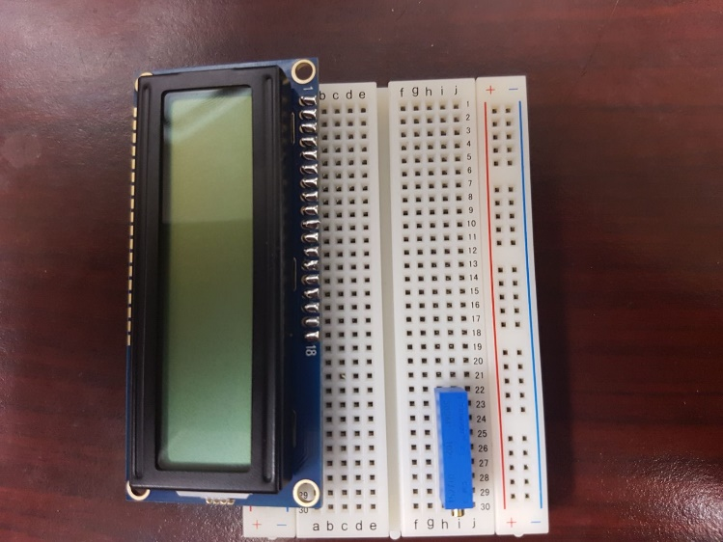

Fig 9.2- LCD Placement on the Breadboard

Part 3 – Interface the LCD to the MSP430

1. The MSP430 runs on 3.3V but as the LCD needs 5V Vcc, we need to connect the LCD to external DC power supply. Set the DC Power supply at 5V. Now connect the Vcc of the power supply to the positive column of the Breadboard and GND of the Power supply to the negative column of the Breadboard. Now that positive and negative columns of the Breadboard are Vcc and GND at 5Volts.
2. Now connect Pin 1 of the LCD to the GND on the Breadboard and Pin 2 of the LCD to the 5V Vcc of the Breadboard.

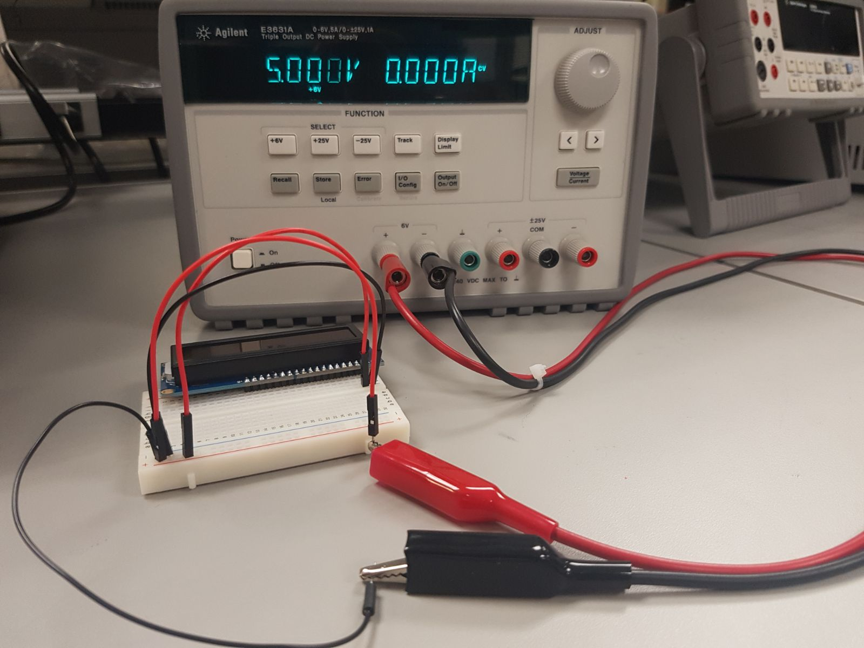

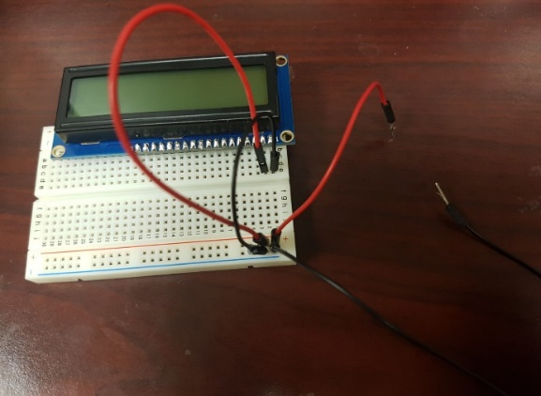

Fig 9.3 Connecting 5V of external power supply to the LCD

1. Place the potentiometer to the opposite corner of your breadboard so that the connections end up clean. Make sure the knob is faced towards the outwards direction so that rotating it with the screwdriver becomes easy. **Connect the leg near the knob to the Vcc of the breadboard and the leg of the Potentiometer on the other side to the GND of the Breadboard. Connect the Potentiometer wiper to pin 3 of the LCD.** Refer the Fig 9.4 for a better understanding.

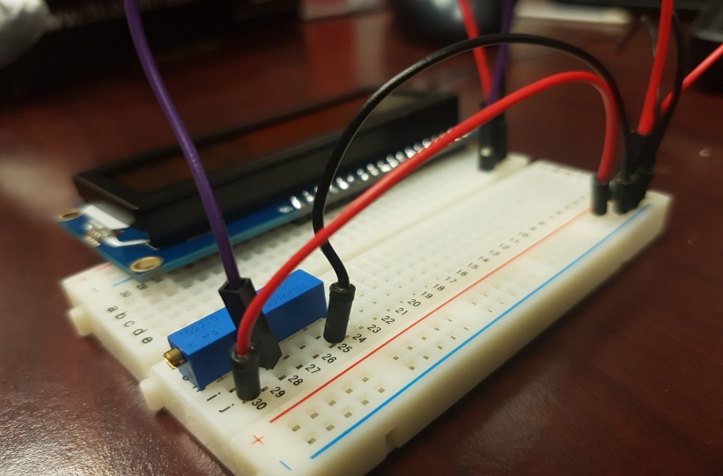

Fig 9.4- The Red wire from the Potentiometer denotes the connections to Vcc and Black wire denotes the connection to GND.

1. Now for the further connections follow the below given figure and table to complete the circuit interfacing of the LCD with the MSP430.

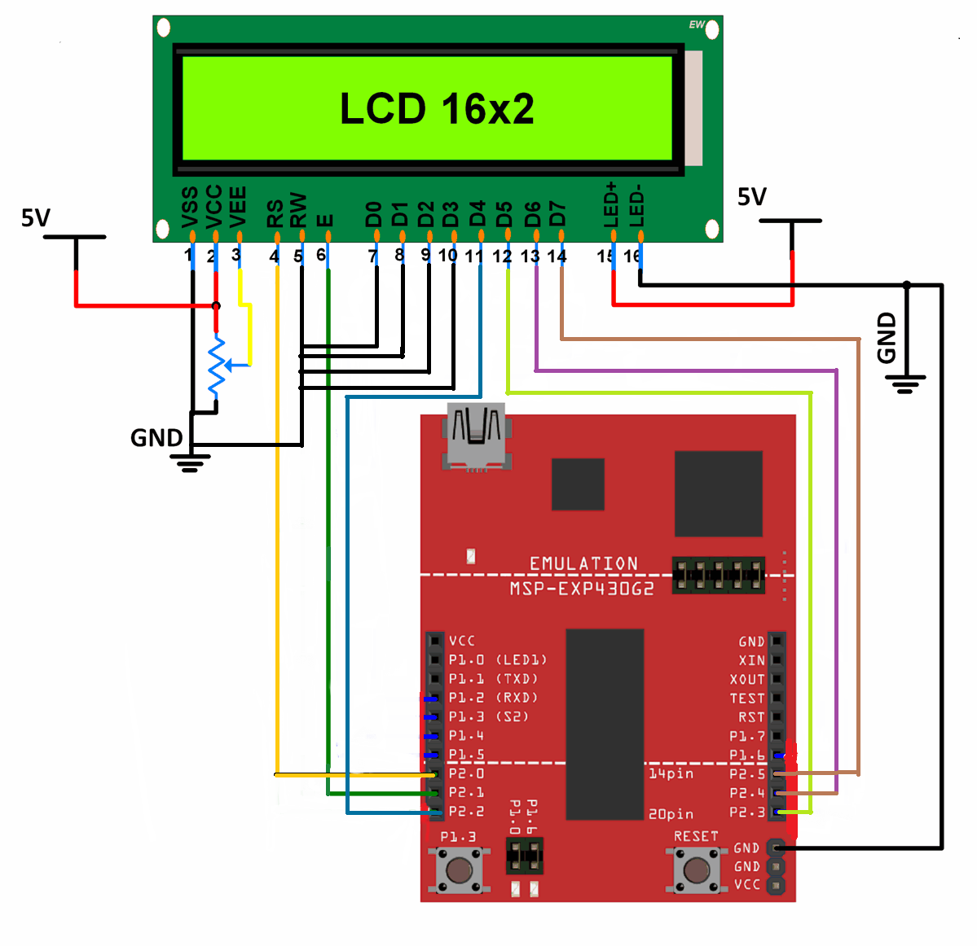

Fig 9.5- Pin interfacing of the LCD and MSP430

**Table 9.1**- LaunchPad -LCD connections for the “Hello World” display.

=================================

LCD pin Connect to

---------------------------------

01 - GND GND, pot

02 - VCC +5V, pot

03 - Contrast Pot wiper

04 - RS Pin8 (P2.0)

05 - R/W GND

06 - EN Pin9 (P2.1)

07 - DB0 GND

08 - DB1 GND

09 - DB2 GND

10 - DB3 GND

11 - DB4 Pin10 (P2.2)

12 - DB5 Pin11 (P2.3)

13 - DB6 Pin12 (P2.4)

14 - DB7 Pin13 (P2.5)

15 - BL+ +5V

16 - BL- GND

=================================

1. Pins 15 and 16, 17 and 18 are responsible for the backlight control of the LCD. Here Pin-15 needs to be connected to 5V Vcc and connecting the ground to Pin 16 gives a Red backlight, whereas connecting the ground to Pin 17 or 18 gives Green and Blue colored backlights respectively. Note that the LCD backlight intensity might be high due to which your results on the LCD would not be visible, which is why we need a potentiometer to dim the brightness of the LCD backlight.
2. To adjust the backlight of the LCD, rotate the potentiometer in the direction in which you can see the digital block brighter and clear.

A circuit board

Description generated with very high confidence

Fig 9.6- LCD backlight brightness reduced to give clearer view of digital blocks

Part 3- Displaying Results on the LCD

1. After interfacing the LCD with your LaunchPad and connecting it to your Laptop, open Energia and go to Files 🡪Examples🡪 Liquid Crystal🡪Hello World

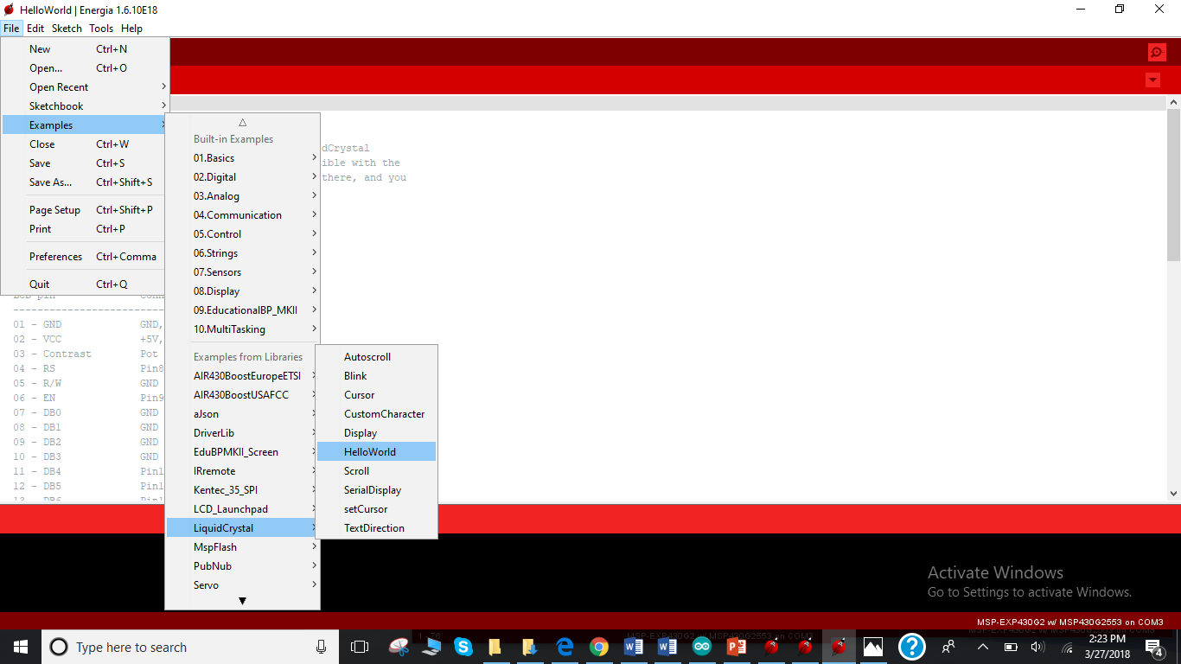

Fig 9.7- Opening the Hello World built-in program in the LiquidCrystal Library

1. Go through the Library Program and Upload the code on your LCD to check whether Hello World pops up on your LCD or not? If it does, it means that your connections are correct, and you can move further and complete the remaining requirements.
2. You may change the color of your back-light and the results at the end would be as shown in Fig 9.8. Can also have other colors as background for the LCD by having 16, 17 and 18 all connected to the ground or by connecting two at a time.

A circuit board

Description generated with very high confidence A circuit board

Description generated with very high confidence A circuit board

Description generated with very high confidence

Fig 9.8- Hello World Code on the LCD with Red, Green and Blue Backlights.

Part 4- Displaying Your Own Innovative Results on the LCD

1. After the Hello World trial with the LCD, now understand the requirement of each line of code in the LiquidCrystal Example.

* To Display some message other than Hello World and change the count speed.
* 9 marks- Scroll your message with a delay enough to read each word being scrolled. Depending upon how well your message is scrolling you will be graded.
* **Write a program, which upon execution, prints up some text and when the PUSH BUTTON is pressed, a SCROLLING text comes up. You can choose your own text.**

Note: You do not need to change any connections that you have already made. Controlling an LCD using a PUSH BUTTON can be done completely by coding in Energia. If you did your homework on your own and understood the LCD interfacing program, it can be done easily. You make take help from the web or the given examples if you need to.

Hint: You do not need to declare any output pins in the setup, only the pushbutton has to be declared as an input. Also make sure to clear the data on the LCD using lcd.clear() before printing on the LCD as you do not want your previous data overwriting the current line that you want to print.

Depending upon how well you control your LCD, you will be awarded 10 or 11 points, which means, you can earn an extra point on this lab if you get an 11/10.